**Photo Editor Using Matlab**

In MATLAB, as always, there are two ways to perform any image processing algorithm,

1. By directly entering the command in the editor/command window.
2. By creating a GUI for the same.

**PROGRAM:**

**1.Using directly the commands in the editor window:**

**Code:**

a = imread('crop.jpg');

subplot(2,3,1);

imshow(a);

b = rgb2gray(a);

subplot(2,3,2);

imshow(b);

c = im2bw(a);

subplot(2,3,3);

imshow(c);

d = imadjust(b);

subplot(2,3,4);

imshow(d);

e = a;

e=rgb2gray(e);

subplot(2,3,5);

imhist(e);

imfinfo('Gated LP-670.jpg')

[height, width, colour_planes] = size(a)

%colormap('spring')

**2. By creating a GUI for the above commands:**

* **For histogram**

a=getappdata(0,'a');

ahist=a;

ahist=rgb2gray(ahist);

axes(handles.axes1);

imhist(ahist);

* **For rgb to grayscale**

a=getappdata(0,'a');

agray=rgb2gray(a);

axes(handles.axes1);

imshow(agray);

* **For upload**

a=uigetfile('.jpg')

a=imread(a);

axes(handles.axes1);

imshow(a);

setappdata(0,'a',a)

* **For reset**

a=getappdata(0,'a');

axes(handles.axes1);

imshow(a);

* **For Complement**

a=getappdata(0,'a');

acomp=a;

acomp=imcomplement(acomp);

axes(handles.axes1);

imshow(acomp);

* **For Edge Direction**

a=getappdata(0,'a');

aedge=a;

aedge=rgb2gray(aedge);

aedge=edge(aedge,'Canny')'

axes(handles.axes1);

imshow(aedge);

* **For clockwise**

a=getappdata(0,'a');

aclock=a;

aclock=imrotate(aclock,270);

axes(handles.axes1);

imshow(aclock)

* **For anticlockwise**

a=getappdata(0,'a');

aclock=a;

aclock=imrotate(aclock,90);

axes(handles.axes1);

imshow(aclock);

**OUTPUT SCREENSHOTS:**

**1.By using direct commands in window:**

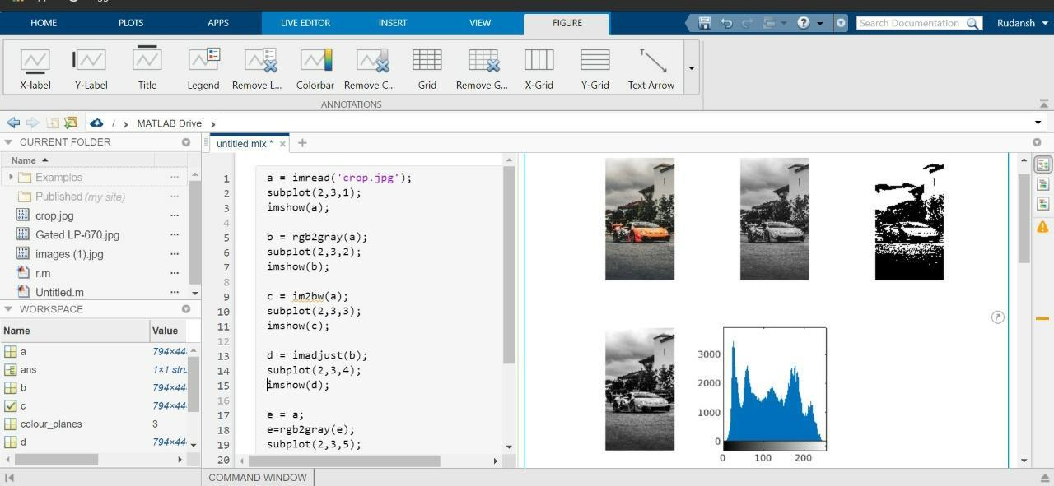

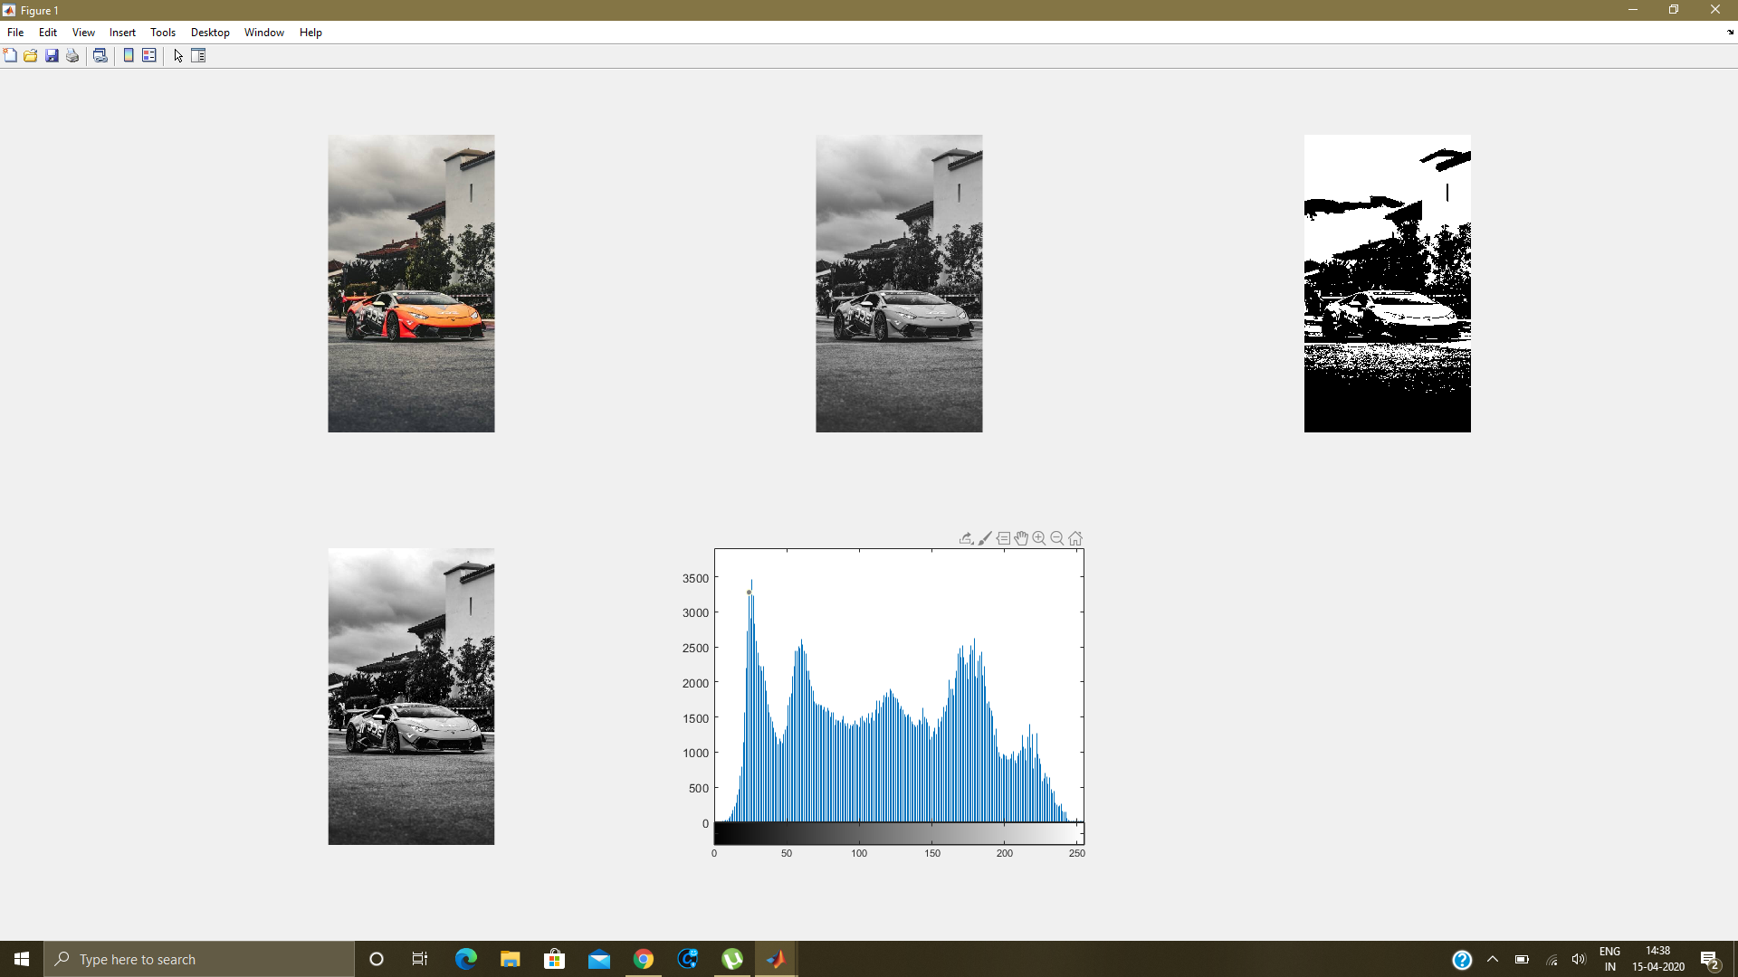

**2. By creating GUI:**

**Layout image: Created using guide option**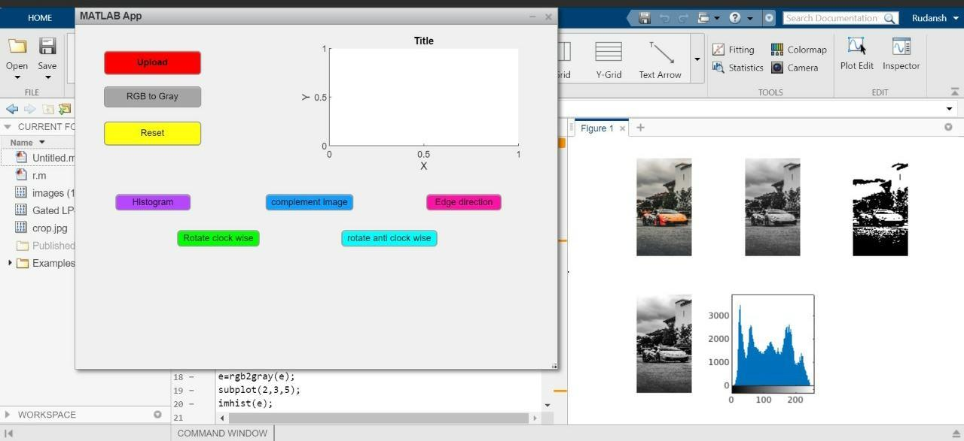

**Output image:**

**(1)Upload Button:**

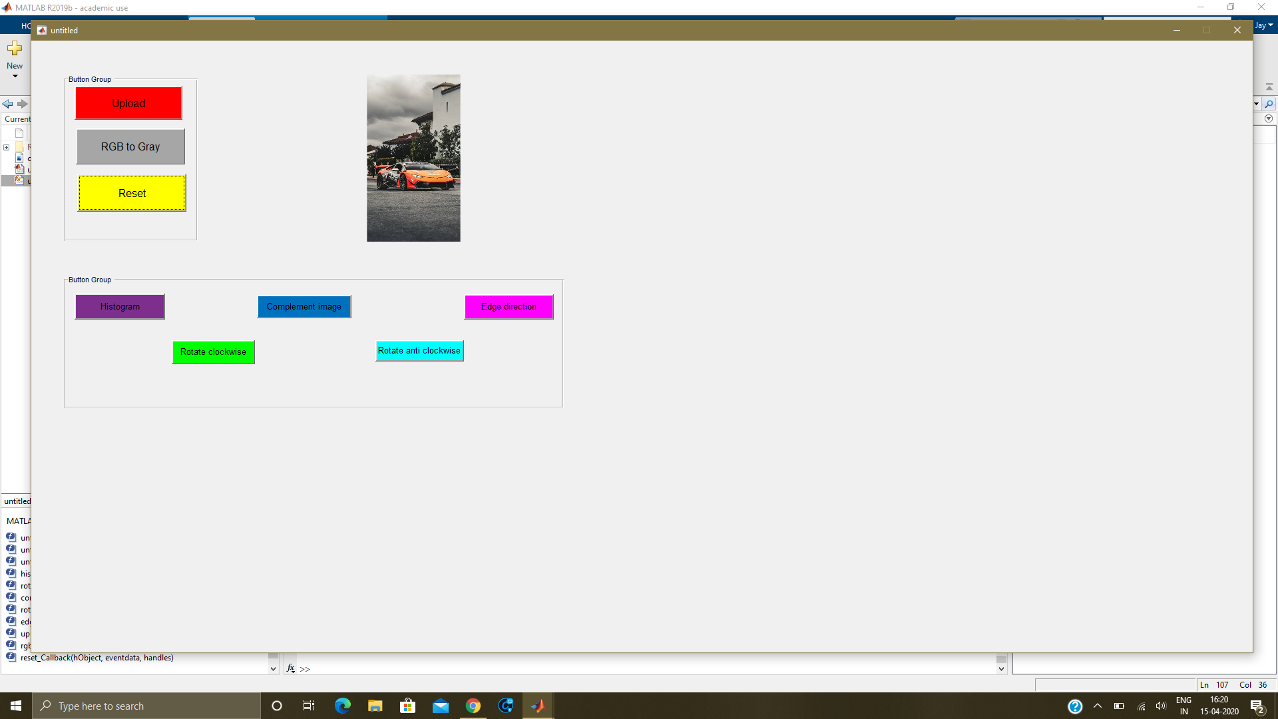

**(2)Rgb to grayscale Button: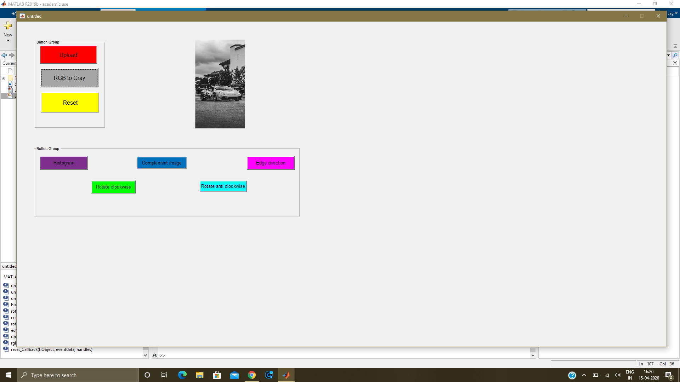(3)Complement Button: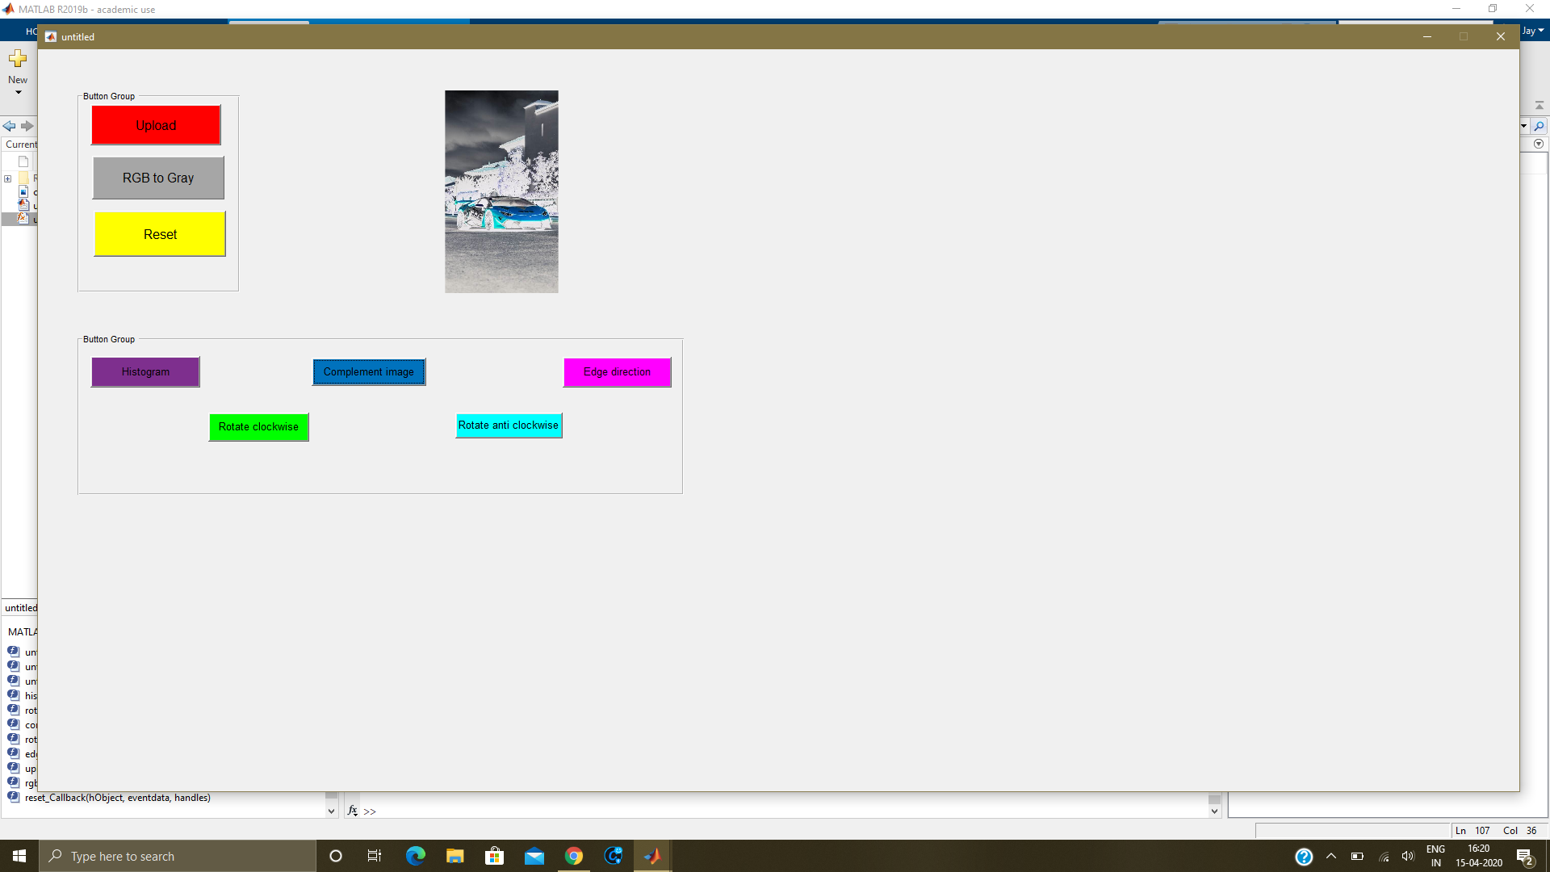(4)Edge Direction Button: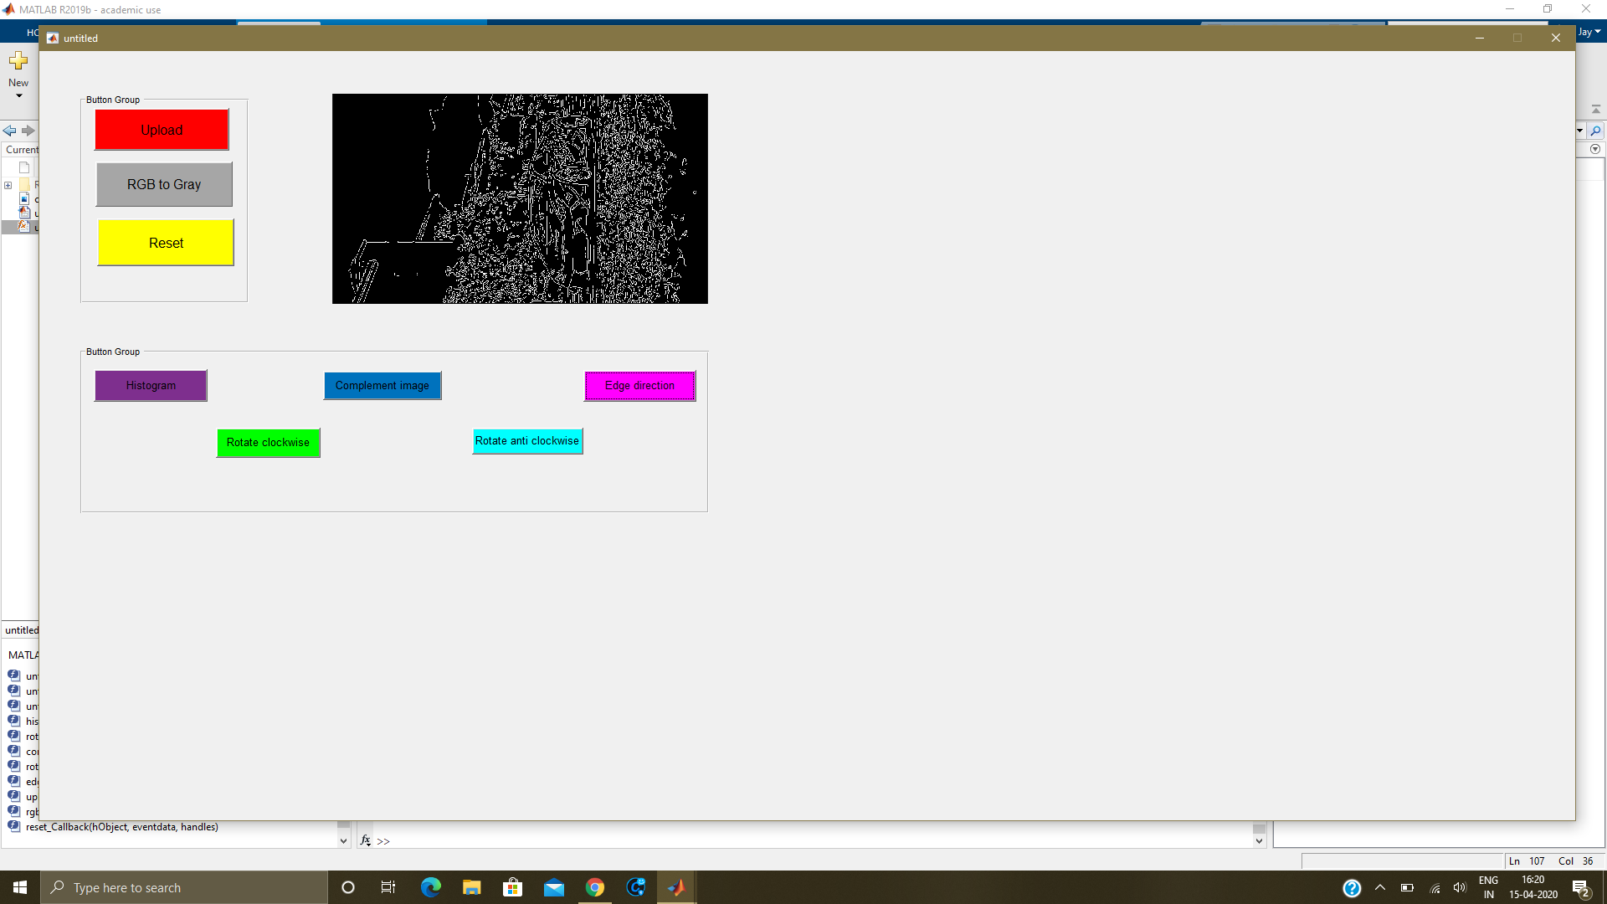(5)Clockwise Button: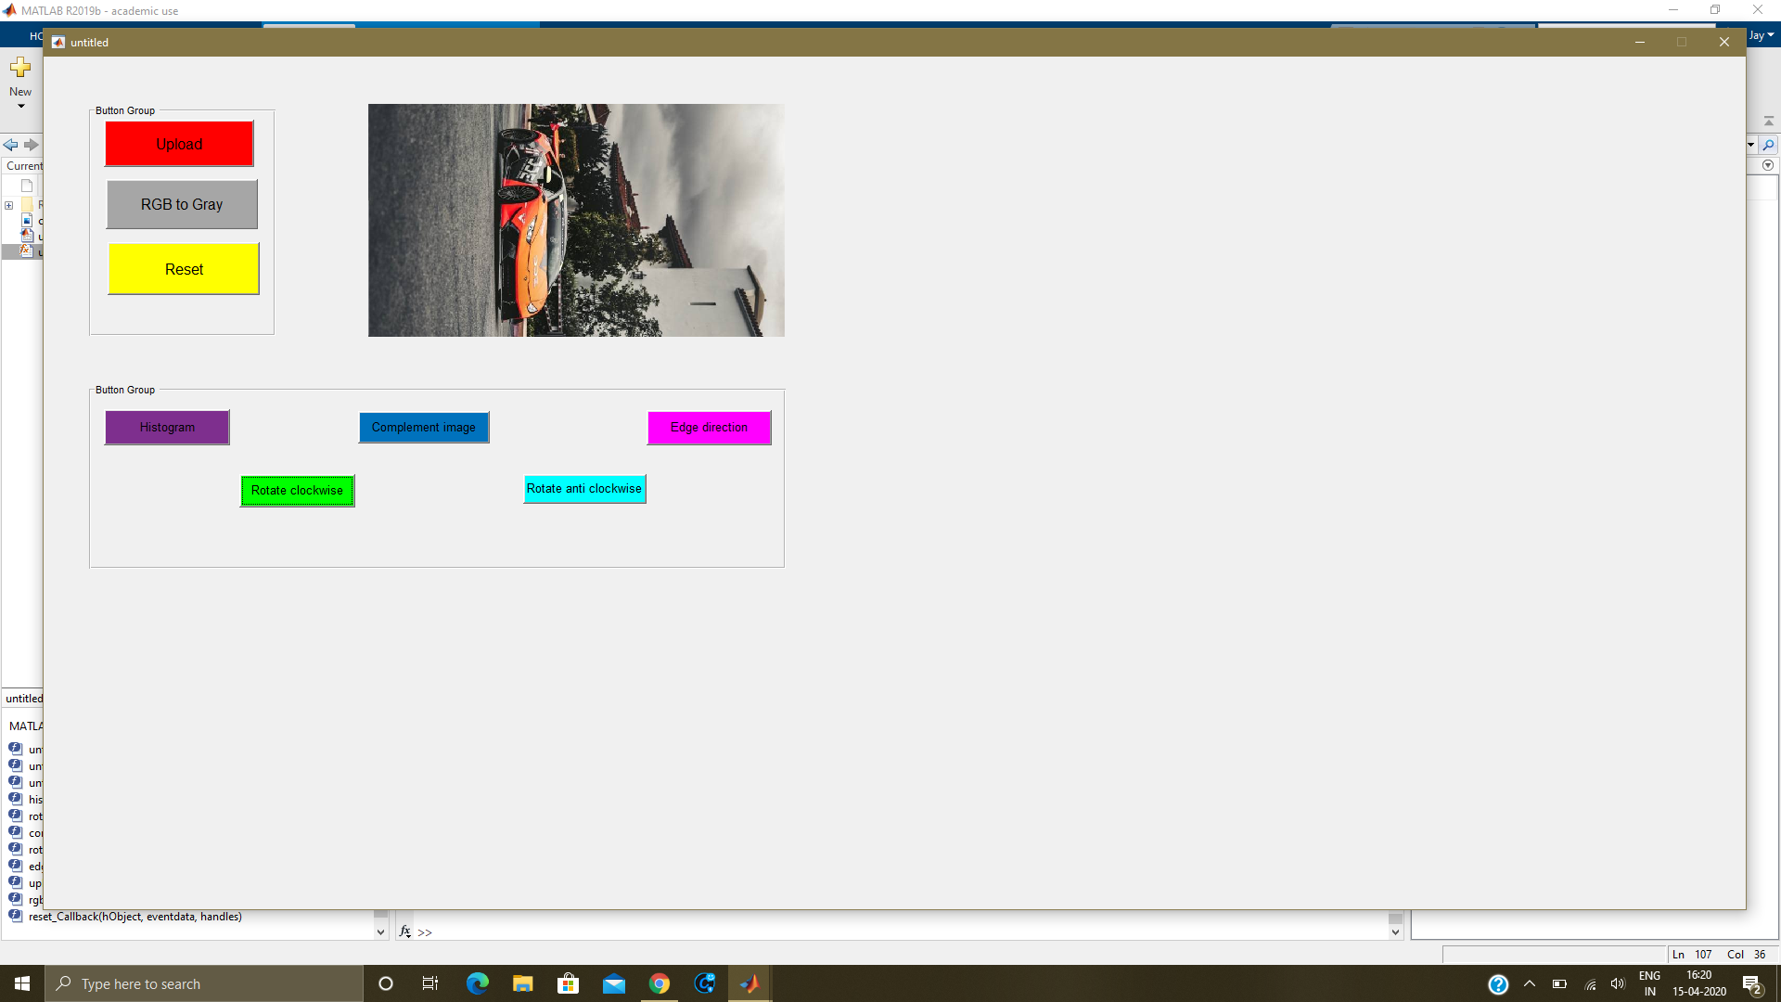(6)Anticlockwise Button: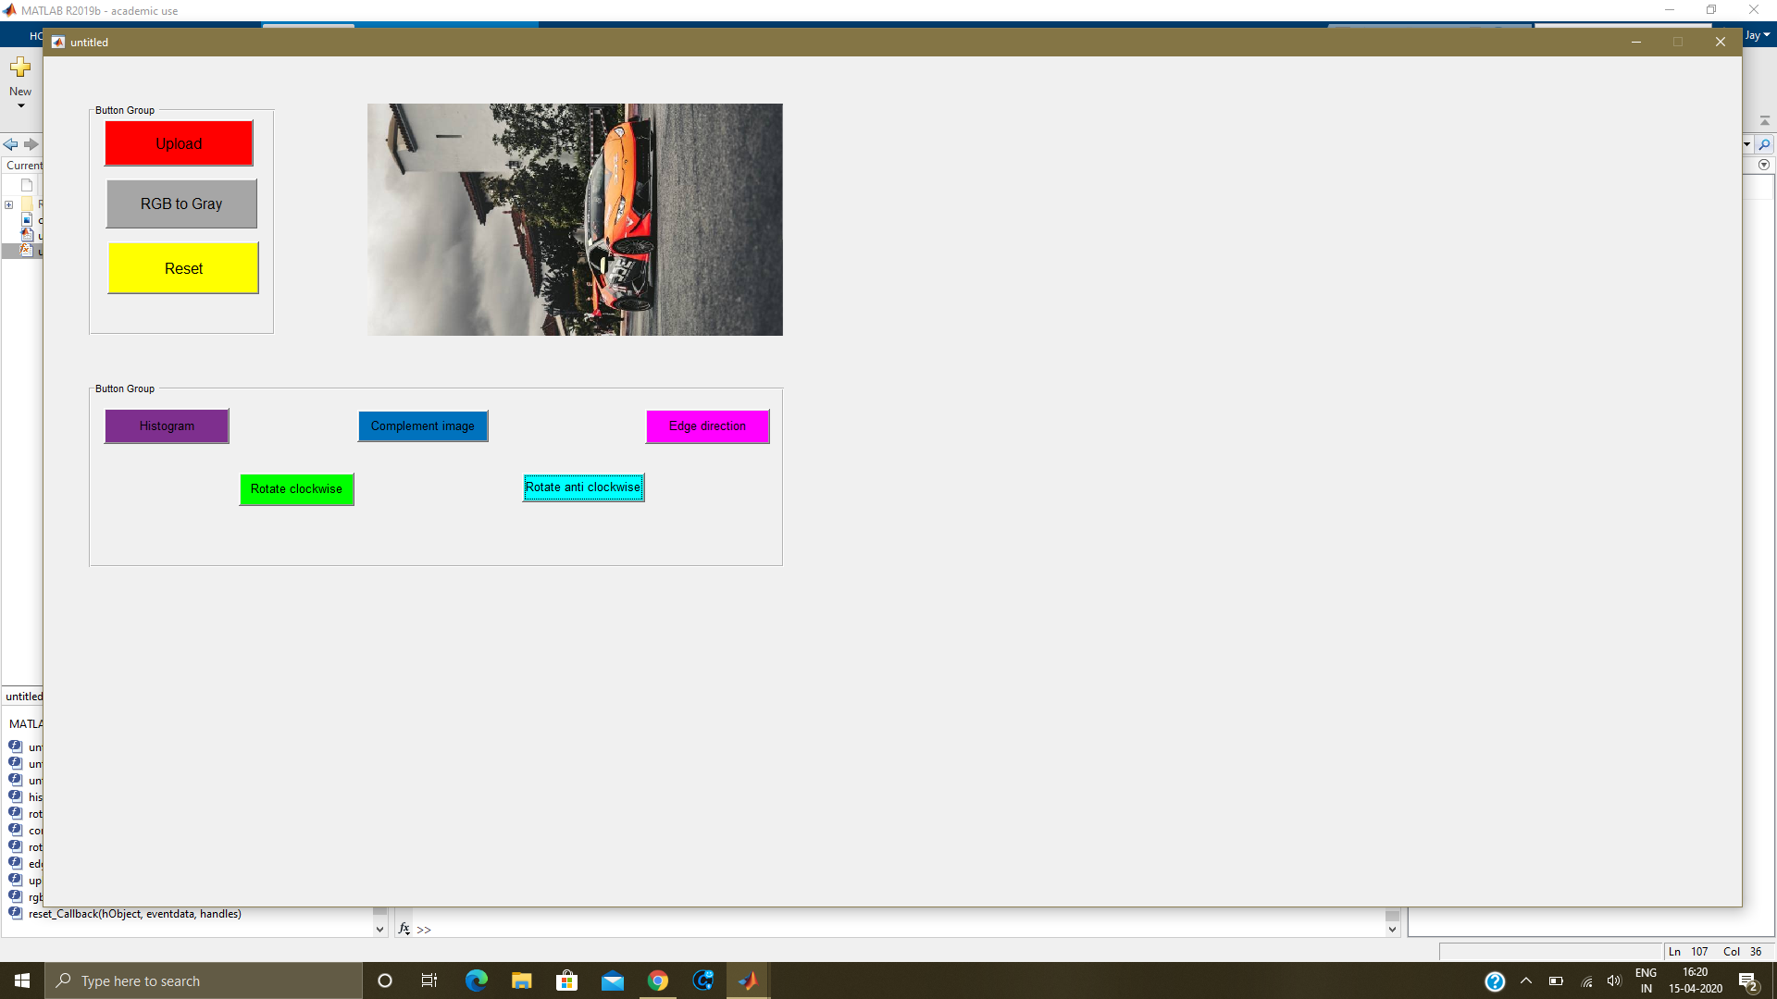(7)Reset Button:**



**(8) Histogram Button:**

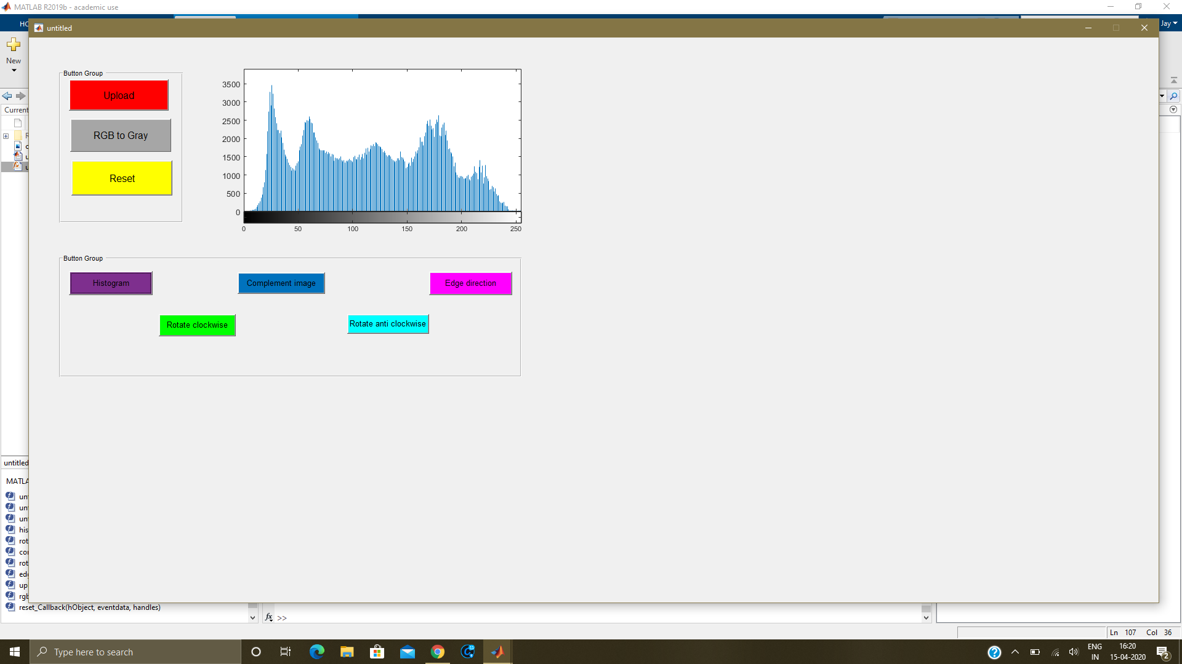

**CONCLUSION:**

**We learnt,**

* **The operations available for Image Processing in Matlab.**
* **How to use GUI in Matlab.**
* **How to Design App Layout using guide.**
* **How to do Image Processing with GUI option.**